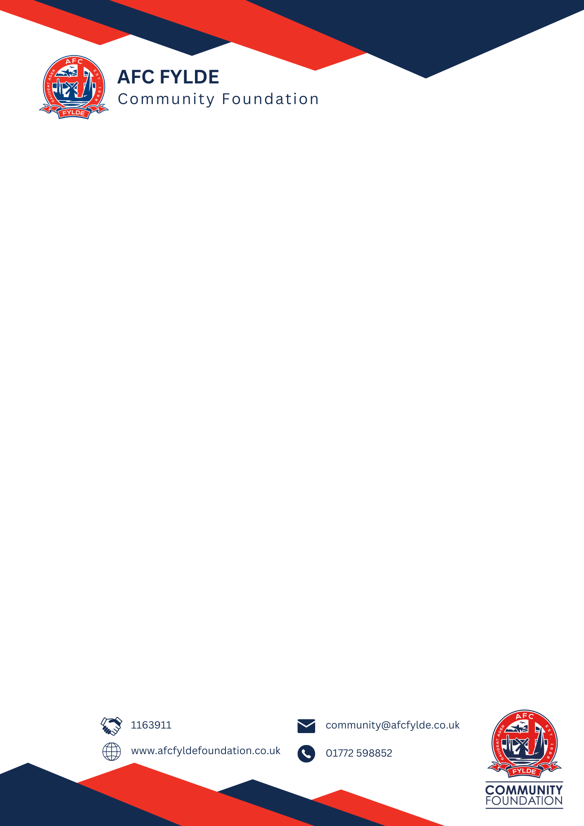
Equality and Diversity form
AFC Fylde Community Foundation sets a huge importance on meeting our aims that are highlighted in our equality policy. This includes not discriminating under the Equality Act 2010 and building an accurate picture of the make-up of the workforce in encouraging equality and diversity.
This form is completely voluntary but the Foundation appreciates any extra co-operation to help us achieve our aims.
If completing this form, please return with your application.
Gender
Man ☐ Woman ☐ Intersex ☐ Non-binary ☐ Prefer not to say ☐
Are you married or in a civil partnership?
Yes ☐ No ☐ Prefer not to say ☐
Age
16-24 ☐ 25-29 ☐ 30-34 ☐ 35-39 ☐ 40-44 ☐ 45-49 ☐
50-54 ☐ 55-59 ☐ 60-64 ☐ 65+ ☐ Prefer not to say ☐
What is your ethnicity?
Ethnic origin is not about nationality, place of birth or citizenship. It is about the group you most identify with.
White
English ☐ Welsh ☐ Northern Irish ☐ Irish ☐ British ☐
Traveller or Irish Traveller ☐ Prefer not to say ☐
Mixed/ multiple ethnic groups
White and Black Caribbean ☐ White and Black African ☐ White and Asian ☐
Prefer not to say ☐ Any other mixed background, please specify:

Asian/Asian British
Indian ☐ Pakistani ☐ Bangladeshi ☐ Chinese ☐ Prefer not to say ☐
Any other Asian background, please specify:
Black/African/Caribbean/Black British
African ☐ Caribbean ☐ Prefer not to say ☐
Any other Black/African/Caribbean background, please specify:
Other ethnic group
Arab ☐ Prefer not to say ☐
Any other ethnic group, please specify:
Do you consider yourself to have a disability or health condition?
Yes ☐ No ☐ Prefer not to say ☐
What is the effect or impact of your disability or health condition on your ability to give your best at work?
Please elaborate here:
This form is purely for monitoring purposes only, however, if you feel like you require a reasonable adjustment, please contact your line manager or the recruitment manager if you’re applying for a job.
What is your sexual orientation?
Heterosexual ☐ Gay ☐ Lesbian ☐ Bisexual ☐ Prefer not to say ☐
If you prefer to use your own term, please specify:
What is your religion or belief?
No religion or belief ☐ Buddhist ☐ Christian ☐ Hindu ☐ Jewish ☐ Muslim ☐
Sikh ☐ Prefer not to say ☐ If other religion or belief, please specify:

What is your current working pattern?
Full-time ☐ Part-time ☐ Prefer not to say ☐
If you have a different type of working pattern, please specify:
Do you have any caring responsibilities? If yes, please tick the relevant ones to yourself.
None ☐ Primary carer of a child/children (under 18) ☐
Primary carer of a disabled child/children ☐
Primary carer of a disabled adult (aged 18 or over) ☐
Primary carer of an elderly person ☐
Secondary carer to any of the above (another person carries out the main caring role) ☐
Prefer not to say ☐
If you have any additional comments, please include them below:

Thank you for taking the time to fill out this form.

